SUPPORTING AGREEMENT
Between__________________________________________
and the partners of the project “Empowering Consumer Organisations: Towards a harmonised approach tackling dual quality in food products”.

- General Information
Name of the consumer organisation:
Address:

Legal representative:
Person of contact:
Starting date:
- Purpose
The objective of this Supporting Agreement is to set forth understandings and intentions of the partners to enable the signatory organisation to carry out the testing campaign and to implement the training material developed during the European Union funded project “Empowering Consumer Organisation: Towards a harmonised approach tackling dual quality in food products”. The partners acknowledge that this Supporting Agreement does not create any obligation to commitment of funds, nor does it constitute a legally binding commitment by one of the partners.
- Goals and Objectives
The European Union funded project “Empowering Consumer Organisation: Towards a harmonised approach tackling dual quality in food products” aims at limiting dual quality practices in food products and at strengthening consumer organisations in the European Union. The project aims to test as many products as possible and collect data in order to tackle the issue of dual food quality. The consumer organisation NAME shares a common interest with the consortium and wishes to help the development of the project to tackle dual quality in food products in the European Union.
- Activities
In order to tackle dual quality in food products, the consumer organisation is able to:
- Suggest products for testing and carry out tests on food products
- Gather and disseminate test results and report potential unfair business practices for mutual learnings
- Use the common online platform
- Translate the content of the material in their own language
- Share the project’s social media pages
- Share the project’s development and the experience of the testing on their own social media pages

Date:  Name of the legal representative:  Signature: | Date:  Name of the legal representative:  Signature:

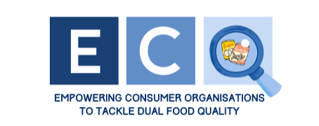

Have some questions or need further information? Do not hesitate to contact us.
SAFE FOOD ADVOCACY EUROPE
Rue de la Science 14
BRUSSELS, BELGIUM
Phone: 0032.2.880.36.46
safe@safefoodadvocacy.eu

